Topic: We are going for sport. Kinds of Sports.
Objectives:
- to develop students' listening, reading, speaking and grammar skills;
- to activate vocabulary ‘Sports and games’ and practice it;
- to improve students’ reading, writing, listening and speaking skills ;
- to motivate them in expressing their own opinion on the topic;
- to develop attention, memory and linguistic guess;
- to enrich pupils’ outlook;
- to bring up positive attitude to sport;
- to motivate students to communicate with each other in English.
Level: Pre – Intermediate
Equipment: a computer, a multimedia projector, a CD player, a CD, HO (a text for reading).
Form: 7
PROCEDURE
I. INTRODUCTION
1. GREETING
T: Good afternoon, dear children. How are you today? I see you are in a good mood, full of energy and ready for the lesson. I am very glad and happy to see all of you today. Today we’ll talk about different kinds of sports, what one should do to keep fit and what qualities a good sportsman should have.
II. WARMING – UP
- Phonetical exercise (rhyme)

I like riding by bicycle
I’m fond of playing chess
My friend is good at judo
We are keen as you can guess
On every kind of sport for sure
As it can even the illness cure
And can for every girl and boy
Bring many moments of joy.
The proverb reads for everybody
’’A sound mind in a sound body’’.

T: What do you do to be healthy? What do you suggest and individual shoud do to keep fit? Sport is probably as old as humanity itself. All over the world people of different ages are very fond of sports and games. Why should people go in for sport?
Complete the word map.
People should go in for sport because they want…

- to lose weight
- to be healthy
- to keep fit
- to make muscules bigger and stronger
- to handle stress

T: So, very well! Tell me please, what do you think about the proverb
A sound mind in a sound body.
Possible answers:
S₁: I agree with this proverb. I think, everyone must do all he can to be healthy.
S₂: To my mind, physically inactive people get old earlier than those who have plenty of exercises.
T: You are right. I can add that being in good health means having both body and mind in good working order free from disease and pain. There is one more proverb:
«Неalth is above wealth» (pupil`s answers)
T: So, what is the topic of our lesson?
2.Checking on Homework
III. MAIN PART
1. VOCABULARY PRACTICE
T: There are lots of different kinds of sports and games. What are they?
Words: cricket, football, rugby, horse – racing, boat – racing, motor – racing, tennis, golf, baseball, hockey, boxing, basketball, volleyball, badminton, handball, darts, chess, running, cycling, jumping, swimming, gymnastics, figure – skating, water polo.
2. LISTENING
T: Listen to the descriptions of the sports and try to guess what kind of sport is it.
- It is a team game. Both men and women can play it. The players have a ball. They play the ball with their hands. There are six players in every team. (Volleyball)
- It is a very popular game in England and in Ukraine. The players kick the ball with their feet. The game lasts 90 minutes and has two halves. The players try to score a goal. (Football)
- It is a very beautiful kind of sport. It gives the sportsmen strength, rhythm and grace. The sportsmen do some exercises and dance to music on the ice. The dancers have very nice costumes on. (Figure – skating)
- This game is played everywhere – in Ukraine and in other countries too. It was first played in the USA. Each of the two teams has five players. They bounce the ball on the floor up and down with one hand. They try to throw the ball into the basket. (Basketball)
- It is a game of two players. Each player starts with sixteen different playing pieces. They move the playing pieces on a board. The aim of the game is taking your opponent's king. (Chess)
3. GRAMMAR PRACTICE
3.1 When do we use…? (Slide 27)
GO – if you speak about sport ending in –ing.
(e.g. I go swimming.)
PLAY – if you speak about ball games (or chess).
(e.g. I play football.)
DO – if you speak about other sports.
(e.g. I do athletics.)
3.2 What sport can we…
GO? skating handball
PLAY? ice – hockey karate
DO? aerobics gymnastics
judo swimming
football athletics
tennis basketball
3.3 Check yourself
GO – skating, swimming;
PLAY – ice – hockey, tennis, football, handball, basketball;
DO – aerobics, judo, karate, gymnastics, athletics.
3.4 T: Complete the sentences using do, play, or go. (Slide 30)
1. Every morning I _________ jogging.
2. On Saturday mornings my brothers ________ football.
3. I _______ gymnastics on Saturdays.
4. My mother and I ___________ aerobics every week.
5. My father and mother _________ golf at the weekend.
6. In winter we ________ skiing.
7. In summer we ________ tennis and ________ swimming.
Key: 1-go, 2-play, 3-do, 4-do, 5-play, 6-go, 7- play, go.
4. RELAXATION
T: Now let's have some rest. Stand up, please.
Hands up, hand down.
Hands on hips, sit down.
Stand up, hands to the sides.
Bend left, bend right.
Hands on hips.
One, two, three – hop.
One, two, three – stop.
Hands up, hands down, sit down.
(A teacher and the students perform the activities.)
5. New Words
Match the pictures with the sports: rafting, skydiving, scuba-diving, rock-climbing, paragliding.
How is the title related to these pictures?
What other extreme sports can you think of?
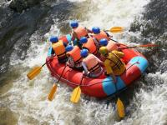
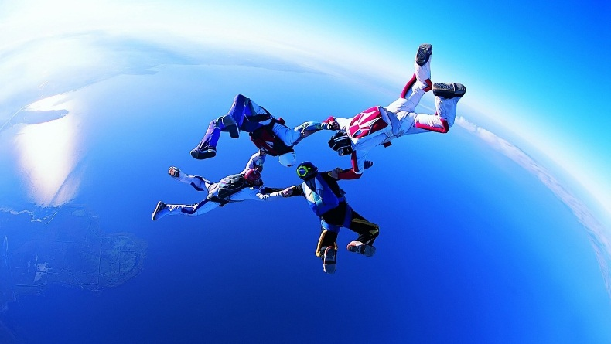
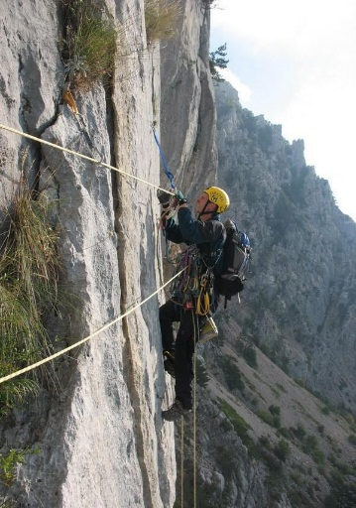
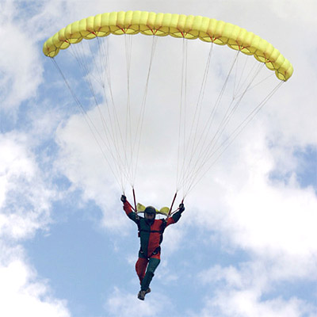
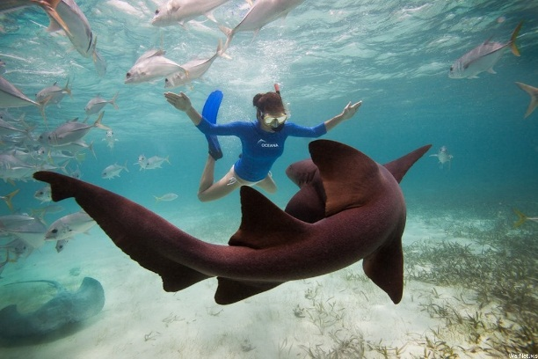
E
A
D
B
C

5. READING
Pre – reading
T: Before you read, try to guess if sport is so important for children.
While – reading
T: Read the paragraphs below and see if you were right.
I am Alison and I am not very fond of sports. I am a bit plump and it is difficult for me to run and jump. I don’t like to compete, but I like to watch sports on TV. Best of all I like watching figure skating. I sometimes go skating myself.
I am Peter. Sport plays a great role in my life. I love every kind of sports – football, hockey, volleyball and basketball. I also play chess and I love to play football. I go to our local football club every spare minute and my dream is to become a football player. I also watch football on TV a lot.
I am Ann. I am not crazy about sports, but I think it is very important to keep in good form and stay healthy. I want to become a model, so I take great care about my body. I go jogging every day and I attend fitness room three times a week. When I have time, I also attend classes of aerobics, but they are quite expensive, so I can't go as often as I want.
My name is Alex. I don’t understand people who think only about sports and physical perfection of their body or watch others doing the same on TV. Such people miss out a lot in their lives. It is much more fun to train brains. In the modern world people do not need muscles, difficult things can be done by machines. I am happy sitting on my sofa with a book or in front of the computer.
Post – reading
- Write down only a name.
- Who is fond of training brains?
- Who likes training football?
- Who likes figure skating?
- Who keeps fit for health and good figure?
- Who hates competing?
- Who is fond of many kinds of sport?
Key: a) Alex; b) Peter; c) Alison; d) Ann; e) Alison; f) Peter.
- Answer the questions
- What is Ann's ambition?
- Why doesn’t Alison like sports?
- How does Alex spend his spare time?
- Why doesn’t Ann often attend classes of aerobics?
- Where does Peter play football?
Key: a) She wants to become a model.
b) She is a bit plump and it is difficult for her to run and jump.
c) He sits on his sofa with a book or in front of the computer.
d) Because they are quite expensive.
e) At the local football club.

6. TRUE/FALSE GAME
T: Repeat the sentence if it's true for you, but say nothing if it's false.
- We go in for sports.
- Sport is popular in Ukraine.
- Sport isn’t very important in our life.
- We are fond of sports.
- I don’t like playing football.
- I like swimming.
- I take part in sport competitions.
- I do morning exercises every day.
7 GAME Doing Crosswords
Look at the photos of three sports people. Can you guess who:
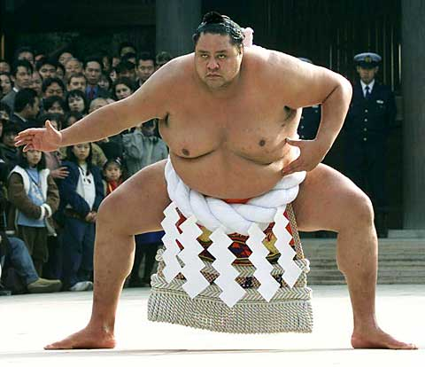  Toshi, from Japan, is training to be a sumo wrestler. | 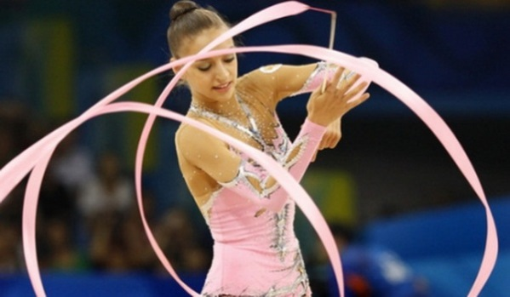  Ania, from Poland, is a champion gymnast. | 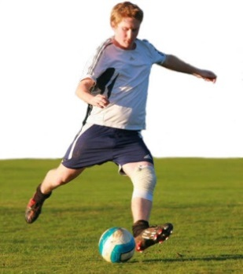  Dan, from Romania, is a professional footballer. He plays for a top Italian club.
a) has a big lunch (with lots of beer) and then goes to sleep for a few hours?
b) doesn’t eat very much?
c) runs 8 km at least four times a week?
d) trains for eight hours every day?
e) usually trains before breakfast?
f) weighs about 40 kg?
g) weighs about 175 kg?
h) is 1.5 m tall?
i) is 1.95 m tall?
j) earns about 50,000 dollars a week?
k) receive money from his/her parents every month?

9. SPEAKING
T: As a result of our lesson, tell us about your favourite kind of sports.
IV. SUMMING – UP
T: What have you learnt at today's lesson? What can you do now?
S₁: I can recognize different kinds of sports.
S₂: I can speak about my favourite kind of sports.
V. HOME ASSIGNMENT
T: Write about your favourite kind of sports using the writing guide.
- My favourite kind of sports is… .
- I think that… .
- I go (play, do)… every … (two times a week).
- I want to… (take part in…, win cups, medals…).

9. SPEAKING
T: As a result of our lesson, tell us about your favourite kind of sports.
IV. SUMMING – UP
T: What have you learnt at today's lesson? What can you do now?
S₁: I can recognize different kinds of sports.
S₂: I can speak about my favourite kind of sports.
V. HOME ASSIGNMEN
T: Write about your favourite kind of sports using the writing guide.
- My favourite kind of sports is… .
- I think that… .
- I go (play, do)… every … (two times a week)

